|  |  |  |  |  |  |
| --- | --- | --- | --- | --- | --- |
| Date | 1-Dec-22 | | | Tester Name | Mayuri Patel |
| Environment | Penfax - Test | | | Login used |  |
| Operating System | Select OS | Version: | Update: | | |
| Software Used | Select Software | Version: | Update: | | |
| Select Software | Version: | Update: | | |
| Release version | 22.4.1 | | | | |
| Title |  | | | | |
| Test Type | Regression | | | | |
| Test Scenario | Confirm Minimum age factor is correct for member age 72 or older (spouse age) | | | | |
|  |  | | | | |
| Expected Results |  | | | | |
| Pass/Fail | Pass | | | JIRA# | N/A |

Describe your steps with screenshots:

Find a member who is 72 or older and Age election Spouse

Open that member profile

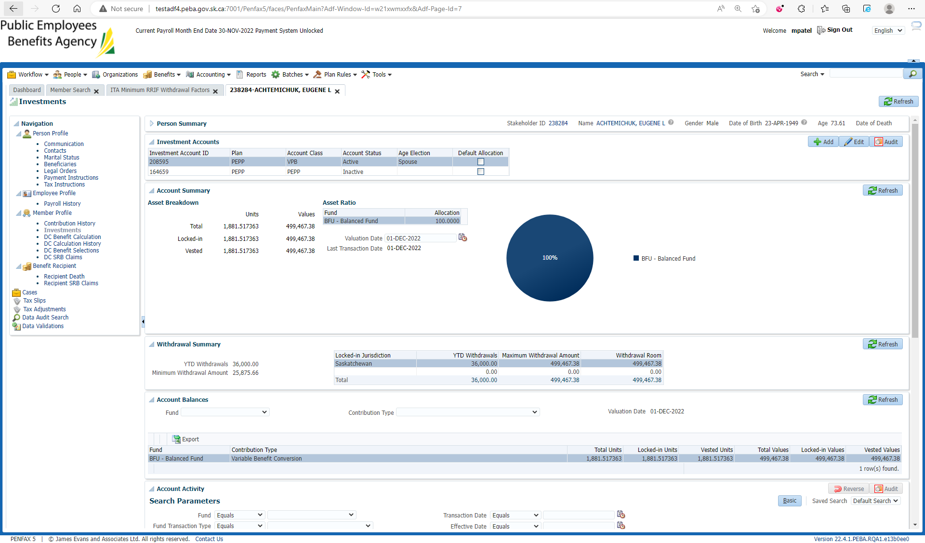

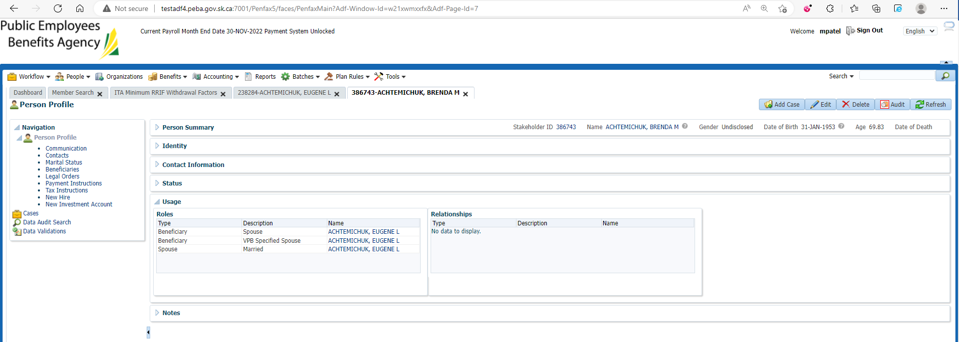

So Spouse Age as on 1-Jan-2022 is 68.XX

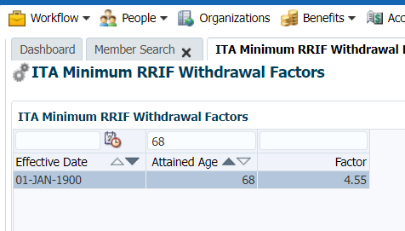

=(568695.91*4.55)/100=25,875.663905, so correct